Software Design

🧠 What is Software Design?
# Source: AI Source: Provided by: [Data Path: Persons Table -> ID Column: 1, Name_En Column: Motasem Essam] -> From: [ChatGPT] on [1/23/2026]
Software Design is the process of planning and structuring a software system before writing the actual code.
👉 It defines how the system will work, how components interact, and how the code is organized

🔑 Simple Definition
# Source: AI Source: Provided by: [Data Path: Persons Table -> ID Column: 1, Name_En Column: Motasem Essam] -> From: [ChatGPT] on [1/23/2026]
Software Design = Blueprint of the software
Just like an architect designs a building before construction, developers design software before coding.

🎯 Why Software Design Matters
# Source: AI Source: Provided by: [Data Path: Persons Table -> ID Column: 1, Name_En Column: Motasem Essam] -> From: [ChatGPT] on [1/23/2026]
- Makes systems organized and scalable
- Reduces complexity
- Improves maintainability
- Helps teams collaborate effectively
- Prevents future problems and rework

🧱 What Does Software Design Include?

1. Architecture
# Source: AI Source: Provided by: [Data Path: Persons Table -> ID Column: 1, Name_En Column: Motasem Essam] -> From: [ChatGPT] on [1/23/2026]
- Overall structure of the system
- Example: Layered architecture (Controller → Service → Repository)

2. Components
# Source: AI Source: Provided by: [Data Path: Persons Table -> ID Column: 1, Name_En Column: Motasem Essam] -> From: [ChatGPT] on [1/23/2026]
- Breaking system into smaller parts (modules/classes)
- Each part has a specific responsibility

3. Data Flow
# Source: AI Source: Provided by: [Data Path: Persons Table -> ID Column: 1, Name_En Column: Motasem Essam] -> From: [ChatGPT] on [1/23/2026]
- How data moves between components

4. Interfaces
# Source: AI Source: Provided by: [Data Path: Persons Table -> ID Column: 1, Name_En Column: Motasem Essam] -> From: [ChatGPT] on [1/23/2026]
- How different parts communicate

5. Design Decisions
# Source: AI Source: Provided by: [Data Path: Persons Table -> ID Column: 1, Name_En Column: Motasem Essam] -> From: [ChatGPT] on [1/23/2026]
- Choosing patterns, tools, and structures

❌ Bad Design Example
# Source: AI Source: Provided by: [Data Path: Persons Table -> ID Column: 1, Name_En Column: Motasem Essam] -> From: [ChatGPT] on [1/23/2026]
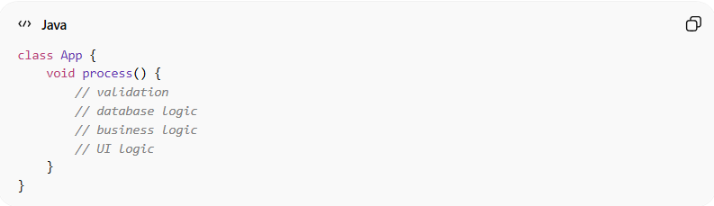
class App {
void process() {
// validation
// database logic
// business logic
// UI logic
}
}
👉 Problems:
- Everything mixed together
- Hard to maintain or scale

✅ Good Design Example
# Source: AI Source: Provided by: [Data Path: Persons Table -> ID Column: 1, Name_En Column: Motasem Essam] -> From: [ChatGPT] on [1/23/2026]
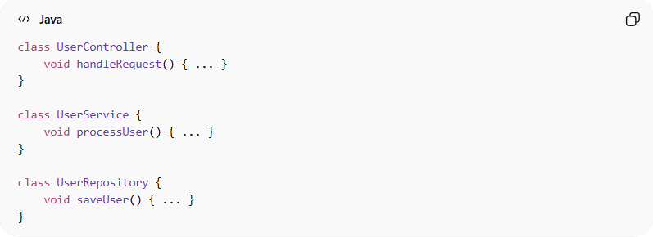
class UserController {
void handleRequest() { ... }
}

class UserService {
void processUser() { ... }
}

class UserRepository {
void saveUser() { ... }
}
👉 Benefits:
- Clear separation of concerns
- Easy to maintain and test

🧭 Types of Software Design

1. High-Level Design (HLD)
# Source: AI Source: Provided by: [Data Path: Persons Table -> ID Column: 1, Name_En Column: Motasem Essam] -> From: [ChatGPT] on [1/23/2026]
- Big picture of the system
- Architecture, modules, interactions

2. Low-Level Design (LLD)
# Source: AI Source: Provided by: [Data Path: Persons Table -> ID Column: 1, Name_En Column: Motasem Essam] -> From: [ChatGPT] on [1/23/2026]
- Detailed design of classes, methods, and logic

💡 Key Idea
# Source: AI Source: Provided by: [Data Path: Persons Table -> ID Column: 1, Name_En Column: Motasem Essam] -> From: [ChatGPT] on [1/23/2026]
Good software design makes coding easier.
Bad design makes even simple changes difficult.

🧾 Summary
# Source: AI Source: Provided by: [Data Path: Persons Table -> ID Column: 1, Name_En Column: Motasem Essam] -> From: [ChatGPT] on [1/23/2026]
Software Design helps you:
- Plan before coding
- Build scalable and maintainable systems
- Reduce bugs and complexity
- Write clean and structured code

